**In Cooperation With**

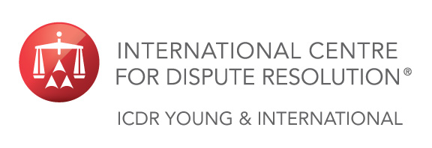

|  |  |  |  |
| --- | --- | --- | --- |
|  |  |  |  |

**Present:**

**Moscow Calling: Interactive Debate with Lawyers, Scholars and Entrepreneurs**

**Voice your opinion on Arbitrator Selection, Arbitration vs. Litigation**

**and Modern Challenges of International ADR in Russia**

**MOSCOW**

**18 SEPTEMBER 2014**

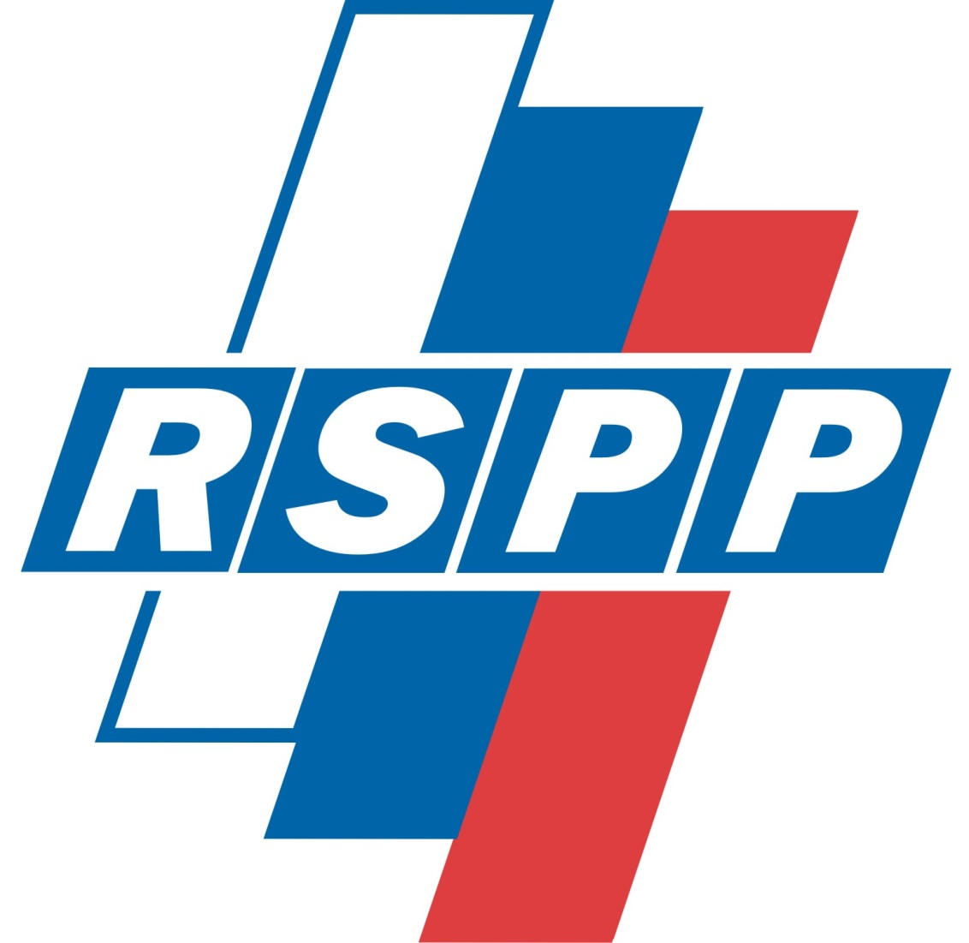

**Hosted by:** The Russian Union of Industrialists and Entrepreneurs (RSPP)

**Venue:** 17 Kotel’nicheskaya Naberezhnaya, Moscow, Russia

**Registration:** 16:00

**Program:** 16:30 – 18:40 followed by a reception

|  |  |  |  |
| --- | --- | --- | --- |
| **Experts:** | **Francesca Albert**  Dechert  *Moscow* | **Anton Asoskov**  Lomonosov Moscow State University  *Moscow* | **Rupert D’Cruz**  Littleton Chambers  *London* |
|  | **Robert Dougans**  Bryan Cave  *London* | **Anna Kozmenko**  Schellenberg Wittmer  *Zurich* | **Kristoffer Löf**  Mannheimer Swartling  *Stockholm* |
|  | **Nane Oganesyan**  Morgan Lewis  *Moscow* | **Alexander N. Shokhin**  RSPP  *Moscow* (invited) | **Andrey Zelenin**  Lidings  *Moscow* |

|  |  |  |  |
| --- | --- | --- | --- |
| **Sponsors:** |  |  |  |

**Registration Form** *Please Print or Type Email Completed Form to: Mandy Sawier at SawierM@adr.org*

|  |  |  |  |  |  |  |  |  |  |  |  |
| --- | --- | --- | --- | --- | --- | --- | --- | --- | --- | --- | --- |
|  | **Mr.** | **Ms.** | **Mrs.** | **Dr.** | | | **Select Language:** | | | **English** | **Russian** |
| **First Name:** |  | | | | **Last Name:** | | |  | | | |
| **Job Title:** |  | | | | **Company:** | | |  | | | |
| **Address:** |  | | | | | | | | | | |
| **City:** |  | | | | **State:** |  | | | **Country:** |  | |
| **Telephone:** |  | | | | **Email:** |  | | | | | |
|  |  | | | |  |  | | | | | |

**This event is free of charge and will be presented in both**

**English and Russian with selected simultaneous translation provided.**